**Daniel Adenisimi**

**School of Biological Science**

**Exploring Dementia Biomarkers and Cognitive Decline: Insights from ADNI-1 Data Analysis**

**Introduction**

Biomarkers play the most important role in assessing disease severity and predicting cognitive decline in dementia. I delved into the Alzheimer's Disease Neuroimaging Initiative (ADNI) database and explored the relationships between selected dementia-related biomarkers and cognitive outcomes in individuals with normal cognition (CN), those with Mild Cognitive Impairment (MCI) and Alzheimer’s Disease (AD).

**Dataset & Methods**

This analysis is based on ADNI-1 datasets extracted from the comprehensive ADNIMERGE file on ADNI database with over 1904836 elements, 16421 rows and 116 columns. The total number of ADNI-1 elements are 7267 and for this summary, I focused on 10 column variables of interest linked to the patient RID of the ADNI-1 dataset (Table 1). These variables are**:**

1. **'RID':** Participant roster ID
2. **'ORIGPROT':** Protocol from which subject originated (ADNI 1)
3. **'VISCODE':** Visit code
4. **'DX_bl':** BaselineDiagnosis
5. **'AGE'**
6. **'APOE4'**
7. **'ABETA':** Alpha beta amyloid
8. **'TAU'**
9. **'PTAU'**
10. **'MMSE':** Mini Mental State Examination

The programming language used is python and all the data analysis, tables and graphs were executed on google colab, a hosted Jupyter Notebook service that requires no setup to use and provides free access to computing resources. Codes and their comments can be found [here](https://colab.research.google.com/drive/1_S0a8WwotSIa8Ju8MxpIkOPc7YRAiaqg?usp=sharing).

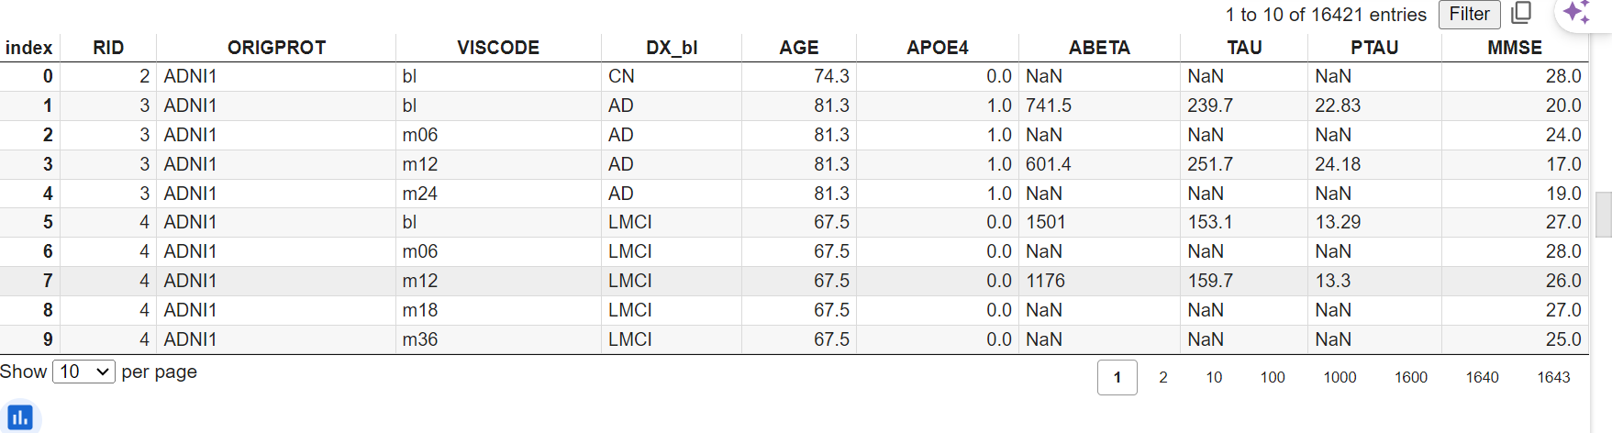

**Table 1:** Displays the first 10 dataset of ADNI-1 variables of interest from ADNIMERGE file

**Table 2:** Shows the first 10 datasets of RID and their VISCODE

**Figure 1:** Bar chart of the first 50 datasets of RID and their VISCODE

**Table 3:** Lists the first 10 datasets of RID and their Baseline Diagnosis

**Figure 2:** Bar chart of first 50 datasets of RID and their Baseline diagnosis

Next, I executed the Pearson correlation coefficients for the selected markers of cognitive impairment (AGE, APOE4, TAU, PTAU) and their correlation with MMSE scores.

|  |  |  |  |  |  |
| --- | --- | --- | --- | --- | --- |
|  | AGE | APOE4 | TAU | PTAU | MMSE |
| AGE | 1.000000 | -0.126162 | 0.066469 | 0.046020 | -0.094294 |
| APOE4 | -0.126162 | 1.000000 | 0.287970 | 0.313813 | -0.261159 |
| TAU | 0.066469 | 0.287970 | 1.000000 | 0.978227 | -0.309256 |
| PTAU | 0.046020 | 0.313813 | 0.978227 | 1.000000 | -0.296978 |
| MMSE | -0.094294 | -0.261159 | -0.309256 | -0.296978 | 1.000000 |

**Table 4:** This Pearson correlation table shows how five different variables are related to each other. Each number shows whether two variables tend to increase or decrease together, or if there's no relationship at all.

A Pearson correlation heat map matrix was created to visualize this relationship.

**Figure 3:** Pearson correlation matrix of selected markers of cognitive impairment from the ADNI-1 datasets

Finally, numerous scatter plots show the relationships between each pair of variables:

1. **AGE**

**Figure 4:** AGE to APOE4 (-0.126162): Very weak negative relationship; as people get older, APOE4 slightly decreases.  (Possibly categorical for APOE4)

**Figure 5:** AGE to TAU (0.066469): Very weak positive relationship; as people get older, TAU slightly increases.

**Figure 6:** AGE to PTAU (0.046020): Very weak positive relationship; as people get older, PTAU slightly increases.

**Figure 7:** AGE to MMSE (-0.094294): Very weak negative relationship; as people get older, MMSE slightly decreases. (Possibly histogram as it is discrete variable)

1. **APOE4**

**Figure 8:**  Moderate positive relationship; higher APOE4 is somewhat associated with higher TAU.

**Figure 9:** APOE4 to PTAU (0.313813): Moderate positive relationship; higher APOE4 is somewhat associated with higher PTAU.

**Figure 10:**  APOE4 to MMSE (-0.261159): Moderate negative relationship; higher APOE4 is somewhat associated with lower MMSE.

1. **TAU**

**Figure 11:** TAU to PTAU (0.978227): Strong positive relationship; higher TAU is strongly associated with higher PTAU.

**Figure 12:** TAU to MMSE (-0.309256): Moderate negative relationship; higher TAU is somewhat associated with lower MMSE.

1. **PTAU**

**Figure 13:** PTAU to MMSE (-0.296978): Moderate negative relationship; higher PTAU is somewhat associated with lower MMSE.

**Conclusion**

This summary highlights significant correlations between dementia-related biomarkers, CN individuals and cognitive decline in those with AD and MCI. The analysis showcases the importance of biomarkers such as APOE4, TAU, and PTAU in predicting cognitive outcomes. The findings set the foundation for exploring this database further on linking inflammation markers to cognitive outcomes.

**Action Plan/Feedback from Sofia**

* Filter data by baseline (RID) only for the time being, this will help with the plots and not skew or create bias within the results e.g., focus on baseline
* Use different graphs/plots depending on the variables
* Explore correlation between Inflammation markers & other dementia biomarkers with MMSE
* Merge Adnimerge with Hulab using both excel and python (You will be doing this a lot)
* Check if the inflammatory markers were measured in CSF or blood
* **Categorize the patient into 3 or 5 age group and correlate to the outcomes or variables.**
* **Multivariate statistics**
* **Pairwise correlation**
* **Categorizing age**
* **Machine learning approach**

**Comparative Analysis of Clinical Dementia Markers, Blood, and CSF Inflammatory Markers in Dementia Diagnosis**

**Hypothesis:** The combined assessment of clinical dementia markers (AGE, TAU_bl, PTAU_bl, ABETA_bl, PTGENDER), blood inflammatory markers (C-Reactive Protein (CRP), Interferon gamma Induced Protein 10 (IP-10), Monokine Induced by Gamma Interferon (MIG), Tumor Necrosis Factor alpha (TNF-alpha)), and CSF inflammatory markers (IL_10, IL_6, TGFBETA2) provides a more accurate diagnostic picture for dementia than standalone evaluation of blood or CSF inflammatory markers.

**Rationale:** The combination of clinical dementia markers with both peripheral (blood) and central (CSF) inflammatory markers may offer a comprehensive view of the disease process, capturing both systemic and neuroinflammatory aspects. This combined approach could enhance the accuracy and specificity of dementia diagnoses, utilizing the strengths of multiple biomarker sources and asserting a holistic diagnostic framework.

**Markers:**

**Clinical dementia**: ‘AGE', 'TAU_bl', 'PTAU_bl', 'ABETA_bl', 'PTGENDER'

**Blood inflammation markers**: ‘C-Reactive Protein (CRP) (ug/mL)', 'Interferon gamma Induced Protein 10 (IP- (pg/ml)', 'Monokine Induced by Gamma Interferon (MI (pg/ml)', 'Tumor Necrosis Factor alpha (TNF-alpha) (pg/mL)'

**CSF Inflammatory markers:** 'IL_10', 'IL_6', 'TGFBETA2'

**Cognitive test marker:** 'CDRSB_bl'

Feedback

ADNI inflammatory marker analysis feedback

CDSBR is seen as a better measure of change in function.

Use logistic regression to combine markers with similar results to improve prediction of disease.

Models: Use ABETA standard model (output could be MMSE/ CDRSB), Use TAU, use tau AND abeta together, add inflammation (markers) +abeta+tau to predict mmse/cdrsb

Next; Add columns for MMSE and CDRSBL at different years/Change output (MMSE at 2YEARS). Keep the rest at baseline. Delta changes could be interesting between the years.